Genie3000



InVitesse Genie  3000

An integrated, fully outsourced
Voice Blast Messaging Service

InVitesse Genie  3000

May 1, 2004

► InVitesse Genie  3000 ◄

Overview
Genie3000
InVitesse Genie 3000 is a service providing automated voice blast as well as web based click and dial CTI services to clients. The voice blasts are set up and controlled via a web based interface, which can be used with minimal training by sales people and research analysts, etc. InVitesse Genie 3000 provides automated email reports of voice blast status – call success or failure, and linked services such as email blasting to client lists. Messages can be recorded either on a PC and uploaded, or by dialing in to our automated telephony service. Once set up, the overnight voice blasts are ‘fire and forget’. The system will automatically notify the user of voice blast completion via email. The interactive voice blast (Voicedrop) conferencing service can be used to individually customize Voiceblast messages to important Clients.

Voice Messenger Screen
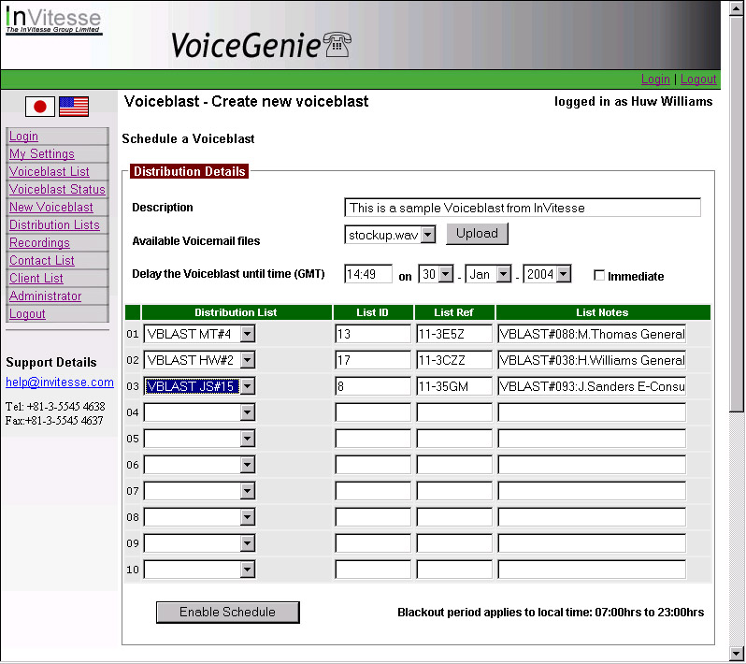

InVitesse Genie can interface to your CRM database
The InVitesse Group has integrated Genie 3000 with database systems at clients (e.g. Siebel CRM) to automate voicemail distribution and to provide special web based voice blast services to their staff. The InVitesse Group can integrate Genie 3000 into your firm’s client database system as well to enable ease of voice blast management using your client data.

Use InVitesse Genie as a service or as lease
Genie3000
In addition to subscribing to InVitesse Genie 3000 voice blast as a service to send automated information to your clients, you may also choose the option to lease an InVitesse Genie 3000 voice blast system to be installed in your office to take advantage of low cost long distance leased line arrangements you may already have in place in your office.

Call Schedule Screen
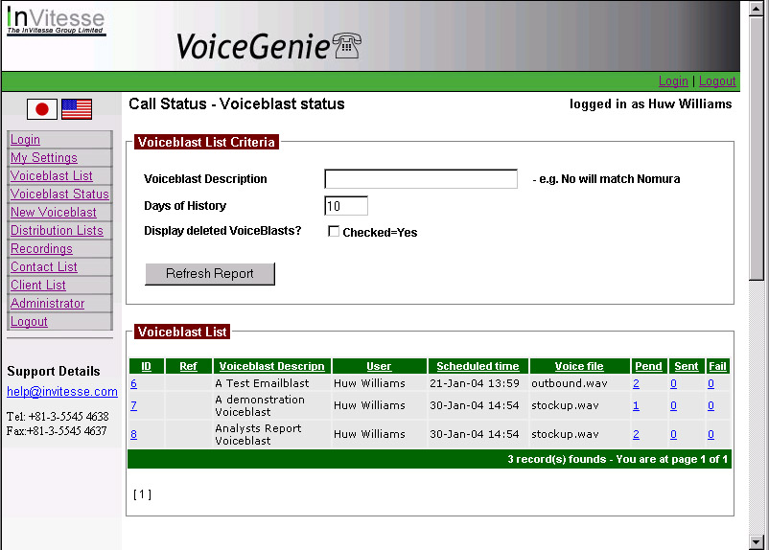

Voicedrop / Interactive conferencing Voiceblast option
Interactive Voiceblast (Voicedrop) is a recent addition to InVitesse Genie 3000. This service allows users of the system to dial clients sequentially, listen to the call progress and where the client picks up the phone, interrupt the voicemail to speak directly to the client without sending the message. Alternatively the user can personalize the message by giving a short welcome at the beginning then start the voicemail. The user can choose different messages for different clients, for example an English, Japanese or Korean message could be delivered depending on the situation.

Asia based, world class fiber infrastructure
InVitesse Genie 3000 services (voice and email blasting) utilize the Japanese Fiber Internet / Telephony / VOIP infrastructure, which is today, one of the most advanced Internet/Telephony networks in the world. This enables us to provide very high quality/high bandwidth services at very competitive pricing. As well, because The InVitesse Group is based in Asia (Tokyo), you can be sure that the right people will be available immediately in the Asia-Pacific time zones to address any issues that may arise. The InVitesse Group has both native English speakers as well as Japanese speakers to serve you.

Full call status reporting over the web and email
Genie3000
The InVitesse Genie 3000 system has full status reporting, both on the web and in the form of email status reports. It has a full detailed automated call tracking and display system, so you can know exactly the status of your blasts at any time. Changes to Reference data are logged and can be reviewed in the Audit trail module.

For more information
Please call or email us (below) to find out more about InVitesse Genie voice blast and mail blast services and products, as well as pricing information. We will be happy to discuss with you options and solutions to fit your business needs.

Feature List
Genie3000
InVitesse Genie 3000 has support for overnight Voiceblast, interactive Voiceblast – (Voicedrop), Click and Dial as well as Email message distribution. The services are all integrated on the same platform and accessible through the same interface.

- Call List Management
Create / amend / delete contacts and clients online
Create / amend / delete distribution lists online
Upload contacts, clients and distribution list files through website
Audit Trails
Support for one or more distribution lists per user.
Sorting and searching functions by client, contact and distribution list

- Telephony features
Dial-in feature for recording and sending Voiceblasts via any touch-tone phone
Upload voice message files through website
Overnight service automatically calls between 11pm-7am in local time of contact
Multi-language introduction messages
Interactive service can be used concurrently with overnight service

- Voiceblast Control
Voiceblasts can be setup through dial-in or website interface
Voiceblasts can be interrupted at any time up to completion.
Emails sent to user and administrator when Voiceblast is created/deleted/completed
Administrator can interrupt any User’s Voiceblast

- Call Logging
Web based status monitor allows immediate viewing of call progress
Call logging records Client, Contact, call duration, time and completion status
Call completion status messages indicate success or reason for failure
- Data Import
Upload of Siebel generated file – Users, Contacts, Clients, Distribution lists
Individual Distribution lists for each User
Voice message files in .wav and .wma format.

- Data Export
Successful calls details for upload to Siebel (or another database)
Failed calls for spreadsheet analysis
Call analysis by User
Voice message files in .wav format

About InVitesse
INVITESSE
The InVitesse Group provides a number of hardware, software and service solutions which link telephony systems with client’s internal databases and systems, as well as with internet services such as the web and email. We also undertake custom development for clients to add telephony functions and CTI features to in-house applications.

Service and Support
The InVitesse Group provide Services and Support, both for our applications as well as more general client requirements.

Systems Consultancy
The InVitesse Group provides Systems Consultancy services with particular focus in the areas of financial research applications, and transaction processing systems. We are able to advise clients on streamlining business process models and workflows either through the use of our solutions, client in-house systems or other third party software.

Project Management
InVitesse Project Managers specialize in the planning and implementation of our software solutions. Our knowledge and years of experience in the financial industry enable us to deliver projects to schedule and which exceed our clients expectations.

Systems Integration
InVitesse will work with clients to integrate our applications with clients’ in-house systems, whether they are bespoke developed or third-party packages.

Systems Support
InVitesse provides both on-site and off-site technical support to our clients depending on the client’s requirements. We can also provide database administration support for our financial database applications.

- Contact Details
InVitesse Sales Director
Louis Leclerc
louis.leclerc@InVitesse.com
Tokyo Japan
Tel: +81-3-5545 4638
Fax:+81-3-5545 4637

