Genie3000

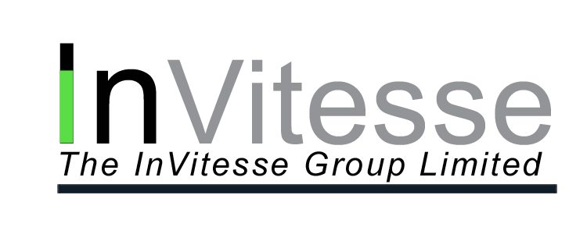

InVitesse Genie  3000

December 10, 2003

► InVitesse Genie  3000 ◄

Overview
Genie3000
InVitesse Genie 3000 is a service to provide automated voice blasting to clients. The voiceblasts are setup via a web based control interface which can be used with minimal training by sales people and research analysts, etc. InVitesse Genie 3000 provides automated email reports of voice blast status – call success or failure, and linked services such as email blasting to client lists. InVitesse Genie 3000 can also provide additional services that enable a recipient to click an emailed hyperlink and then automatically receive requested information in private over the telephone.

Voice Messenger Screen
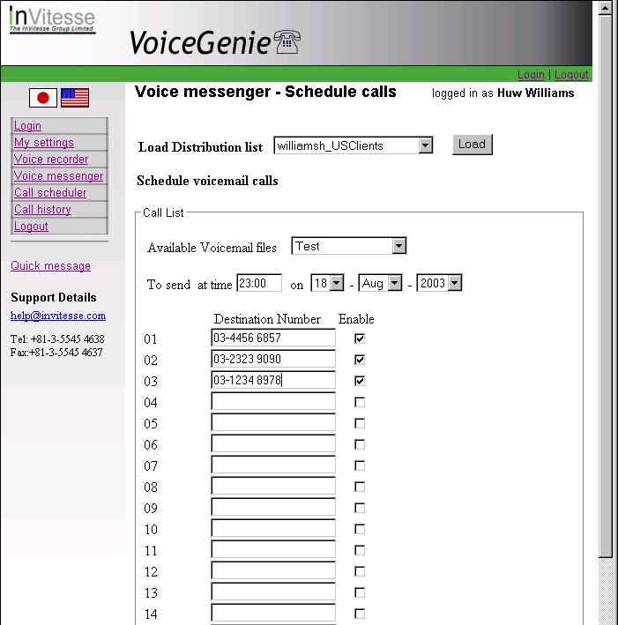
The InVitesse Group has integrated Genie 3000
with database systems at clients (e.g. Siebel CRM) to automate voicemail distribution and to provide special web based voice blast services to their staff. The InVitesse Group can integrate Genie 3000 into your firm’s client database system as well to enable ease of voice blast management using your client data.

In addition to subscribing to InVitesse Genie 3000 voice blast as a service to send automated information to your clients, you may also choose the option to lease an InVitesse Genie 3000 voice blast system to be installed in your office to take advantage of low cost long distance leased line arrangements you may already have in place in your office.

Call Schedule Screen

An enhancement to InVitesse Genie 3000 for interactive voice blast is available. This feature allows users of the system to dial clients sequentially, listen to the call progress and where the client picks up the phone, interrupt the voicemail to speak directly to the client without sending the message.

Genie3000
InVitesse Genie 3000 services (voice and email blasting) utilize the Japanese Fiber Internet / VOIP infrastructure, which is today, the most advanced Internet/Telephony network in the world. This enables us to provide very high quality/high bandwidth services at very competitive pricing. As well, because The InVitesse Group is based in Asia (Tokyo), you can be sure that the right people will be available immediately in your time zone to address any issues that may arise. The InVitesse has both native English speakers as well as Japanese speakers to serve you.

The InVitesse Genie 3000 system has full status reporting, both on the web and in the form of email status reports. It also has a full detailed automated call tracking and display system, so you can know exactly the status of your blasts at any time.

Please call or email us to find out more about InVitesse Genie voice blast and mail blast services and products, as well as pricing information. We will be happy to discuss with you options and solutions to fit your business needs.

About InVitesse
The InVitesse Group provides a number of hardware, software and service solutions which link telephony systems with client’s internal databases and systems, as well as with internet services such as the web and email. We also undertake custom development for clients to add telephony functions to in-house applications.
INVITESSE

Service and Support
The InVitesse Group provide Services and Support, both for our applications as well as more general client requirements.

Systems Consultancy
The InVitesse Group provides Systems Consultancy services with particular focus in the areas of financial research applications, and transaction processing systems. We are able to advise clients on streamlining business process models and workflows either through the use of our solutions, client in-house systems or other third party software.

Project Management
InVitesse Project Managers specialize in the planning and implementation of our software solutions. Our knowledge and years of experience in the financial industry enable us to deliver projects to schedule and which exceed our clients expectations.

Systems Integration
InVitesse will work with clients to integrate our applications with clients’ in-house systems, whether they are bespoke developed or third-party packages.

Systems Support
InVitesse provides both on-site and off-site technical support to our clients depending on the client’s requirements. We can also provide database administration support for our financial database applications.

Contact Details
InVitesse Genie 3000 Sales Director
Louis Leclerc
louis.leclerc@InVitesse.com
The InVitesse Group
Tokyo, Japan
Tel: +81-3-5545 4638
Fax:+81-3-5545 4637

