

SilkFire Overview

Version 1.0.14
28 July 2004

Document provided by A SilkRoad Partner
SilkFire
SilkFire Overview

Purpose

The purpose of this document is to provide an overview of the functionality available within SilkFire, and how the functionality is used.
The document covers :
- an introduction to SilkFire
- an overview of the functions
- configuration instructions
- daily automatic procedures for printing reports
- manual procedures for printing reports

An Introduction to SilkFire

SilkFire is a Financial Information Reporting system which provides automatic generation of regulatory reports from a variety of data sources. It retains imported data in a data repository, and populates the relevant reports using that data. These reports are generally scheduled to run automatically using an administrative tool, but can be run manually – for example to print a historic report.
SilkFire is made up of a number of components (see also the diagram below) :
- a data repository (SilkJPComplianceDB), holding the imported data used in producing the reports
- tables (in SilkJPComplianceDB) holding details of global static data (such as company name, chairman’s name), and report specific static data (such as, person responsible for a report, person’s telephone number)
- tables (in ReportXchangeDB), holding details of the profiles of reports – schedules, location of templates, and so on
- SilkFire Server, which is a set of stored procedures, which are used to insert and extract the data from the database
- ReportXchange Server, which is an NT service which manages the scheduling of the importing of data to the system, and the automatic printing of the reports based on schedules set up (it uses the SilkFire Server stored procedures to do much of this work)
- ReportXchange Admin, which is a client program which has two main functions :
  - the set up and maintenance of the profiles of the reports, details of the scheduling of those reports, and so on
  - the manual viewing, or printing of reports on an ad-hoc basis.

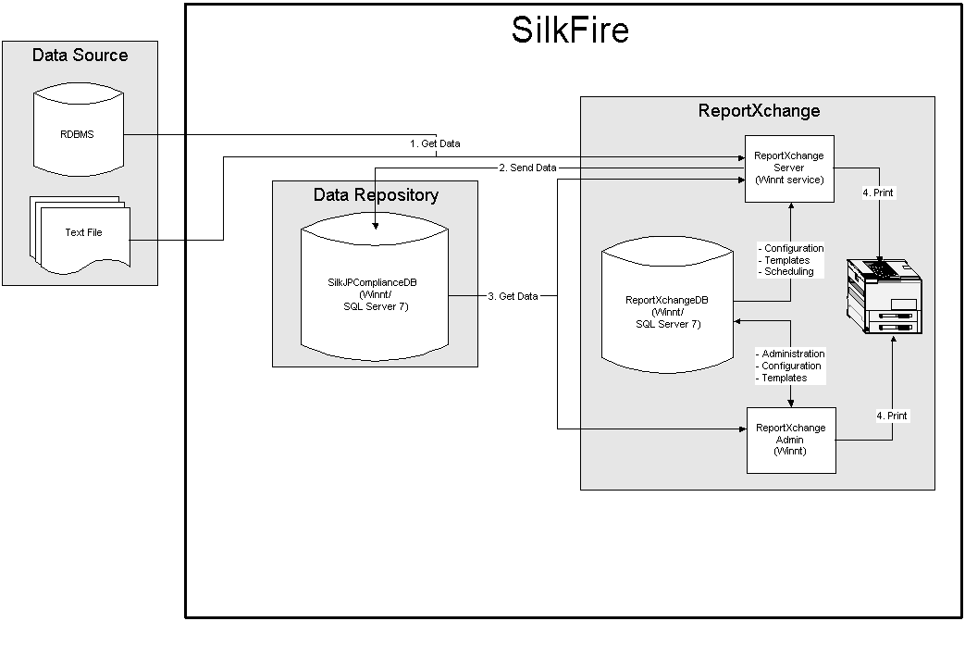
Current Report Coverage
The SilkFire package comprises the three internal Legal Ledgers, and 103 separate Regulatory Reports covering the common Equities, Fixed Income and Derivatives market requirements.
The reports currently supported are listed below; the frequencies of the reports are coded as follows:
I Internal Ledgers
D Daily
W Weekly
M Monthly
SA Semi-annually
A Annually

Local Legal Ledgers
Freq Description
I Daily Transaction Blotter
I Principal Account Trading Ledger
I Client Account Ledger
Bank of Japan Reports
Freq Description
M Yen-denominated Security Trade Report
M Report of interest and dividends paid on foreign securities
M Report of interest and dividends received on foreign securities
M Report of Borrow/Loan Trades in Yen Denominated Securities
A Balance Report of Discount Public/Corporate Bonds
A Report of Non-Resident Investment Balance in Yen-denominated, Resident Issued Securities
A Report for Investment Balances in Yen-denominated Foreign Bonds (Samurai-Bonds)
D Yen-denominated Securities Trade Report (large transaction)
D Foreign Currency Denominated Securities Trade Report (large transaction)
D Yen-denominated Securities Trade Report
M Yen-denominated Security (Gensaki) Trade Report
M Report of Coupon, dividend and other payment
FSA Reports
M Shuyo Kanjo Zandakahyo (Major Account Balance)
M Shuyo Kanjo Zandakahyo (Major Account Balance)
M Monthly Report to MOF for Capital Adequacy Ratio
M Report of Security Underwriting and Trading
SA Statement of Commodity Securities
SA Detail List of Investment Securities
SA Details List of Borrowing Securities
SA Details of Loan Payable –MOF
SA Details of Loan Payable –MOF
JSD Reports
M Report of Public/Corporate Bond OTC Trades by Product Classification
M Report of Public/Corporate Bond Trades by Investor Classification
M Report of Government Bond Trade by Investor Classification
M Bond Borrow/Loan Trade Report
M Domestic CP Trade Activity Status Report
M Certificate of loan credit transaction
M Private placement transaction
M Public/Corporate Gensaki Trade Report (JASDA)
M Bond OTC Option Trade Report (foreign bonds)
M Bond OTC Option Trade Report (total)
M Foreign securities transaction
M Foreign securities transaction
M Foreign Currency Denominated Security Gensaki Trade Report
M Report of Financial Derivative Product Trades
M Report for Securities Trades of Deposit Money
M Report of Stock and Bond Trade Volume by Prefecture
M Report of Foreign Investors Trades in Japanese Securities
M Foreign Currency Denominated Securities Bond Borrow/Loan Trade Report
M Report of OTC Securities Transactions
A Report of Investment Balance in Foreign Securities
A Report of Investment Balance in Foreign Securities
SA Report of OTC derivatives trade
M Report of deposit money against securities Trades by trade type
M Total margin trade current position report (total)
Osaka Exchange Reports (OSE trades)
W Stock price index future trade (trade) contents report of investment section type (quantity)
W Stock price index future trade (trade) contents report of investment section type (amount)
W Stock price index future trade position contents report of investment section type
W Stock price option trade (trade) contents report of investment section type (quantity)
W Stock price option trade (trade) contents report of investment section type (quantity)
W Stock price option trade (trade) contents report of investment section type (trade amount)
W Stock price option trade (trade) contents report of investment section type (trade amount)
W Stock price option trade (trade) contents report of investment section type (trade amount)
W Stock price option trade (trade) contents report of investment section type (trade amount)
W Equity option trade (trade) contents report of investment section type (quantity)
W Equity option trade (trade) contents report of investment section type (quantity)
W Equity option trade (trade) contents report of investment section type (trading amount)
W Equity option trade (trade) contents report of investment section type (trading amount)
W Equity option trade position contents report of investment section type
W Equity option trade position contents report of investment section type
W Stock price index future trade (trade) contents report of investment section type (qty) business type index
W Stock price index future trade (trade) contents report of investment section type (amt) business type index
W Stock price index future trade position contents report of investment section type business type index
W Stock price option trade (trade) contents report of investment section type (quantity) business type index
W Stock price option trade (trade) contents report of investment section type (trade amt) business type index
W Stock price option trade position contents report of investment section type (trade amt) business type index
W Stock price option trade (trade) contents report of investment section type (quantity) business type index
W Stock price option trade (trade) contents report of investment section type (trade amt) business type index
W Stock price option trade position contents report of investment section type (trade amt) business type index
Tokyo Exchange Reports (TSE trades)
D Margin trade balance report of issue type
W Margin trade balance report of issue type as of weekend
W Total margin trade current position report (total)
W Stock price index future trade (trade) contents report of investment section type (trading balance)
W Stock price index future trade (trade) contents report of investment section type (trading contract amount)
W Stock price index future trade position contents report of investment section type (trading contract amount)
W Stock price option trade (trade) contents report of investment section type (trading balance)
W Stock price option trade (trade) contents report of investment section type (trading amount)
W Stock price option trade (trade) contents report of investment section type (trading contract amount)
W Stock price option trade exercise of options contents report of investment section type
W Stock price option trade position contents report of investment section type
W Future trading (trading) detail report of investment section type TSE (10Y)
W Future trading position contents report of investment section type TSE (10Y)
W JGB future option trade (trade) contents report of investment section type TSE (trading balance)
W JGB future option trade (trade) contents report of investment section type TSE (trading amount)
W JGB future option trade (trade) contents report of investment section type TSE (trading contract amount)
W JGB future option trade exercise of options contents report of investment section type
W JGB future option trade position contents report of investment section type
W Future trading (trading) detail report of investment section type TSE (20Y)
W Future trading position contents report of investment section type TSE (20Y)
W Future trading (trading) detail report of investment section type TSE (5Y)
Ad-Hoc Bond Futures 5YJGB/Position/Hundred Million Yen
|W Equity Option/Transaction/Quantity
W Equity Option/Transaction/Yen
W Equity Option/Exercised/ Quantity
W Equity Option/Exercised/ Quantity
Ad-Hoc Equity Option/Position/Quantity
W Sales of Listed Convertible Bonds
W Sales Report (First Section)
W Sales Report of Margin Transactions (Second Section)
M Sales Report (Foreign Stock)
M Sales Report (Beneficiary Certificate of Trust)
M Trading Volume of Listed Securities - at the Tokyo Stock Market
M Sales Report of Stock Trading by Foreign Investor

Some sample report templates are included in the appendix of this document.
An Overview of the Functions

There are a number of separate sets of functions within SilkFire. These can be grouped as follows :
- maintenance functions to set up details of reports, calendars, schedules, etc. This is done through the Maintenance menu in ReportXchange Admin
- importing of the data feed files. This is done automatically on a scheduled basis by ReportXchange Server
- automatic printing of reports. This is also done automatically on an scheduled basis by ReportXchange Server
- manual printing of reports. this is done either through the Maintenance/Process or the File/Report Explorer functionality within ReportXchange Admin.
Maintenance / Set Up Functions
Prior to running any reports it is necessary to set up details about the reports. This is done from the Maintenance menu in ReportXchange Admin. The following should be set up :
- address
- report profile
- schedule
- calendar
- group
- process.

The maintenance functions are used to set up and maintain a number of entities. These are very inter-related, and therefore it is worth firstly giving an explanation of them, and how they interact.
Address
The address is the building block of the reporting process. An address can be an Excel file, a Crystal Report, a file, or a stored procedure. It can be the source or the target of a set of data.
When an address is set up, it contains, at least, the type and the location of the Excel file, Crystal Report file, or stored procedure.
Report Profile
A report profile holds a number of pieces of information about a report.
Primarily it has the source address (that is, the address where the data is coming from for the particular report), and the target address (that is, where the source data is to be fed).
It also holds information about any parameters to be requested at run-time. This is particularly relevant for spreadsheet reports where a data parameter may have to be input.
Finally it holds information about the users who have permission to use the report profile.
It is worth noting that this procedure is also used to set up the data transfer process – where a data feed file is the source address, and the target address is a stored procedure which writes the data away to the SilkFire data repository.
Report Template
Report templates are not maintained via the maintenance menu, however they are integral to some of the maintenance functions, and are therefore explained here.
A report template is essentially a stored version of a report profile, but with enough information to print it. That is, with printer details, and most importantly, any parameters completed – for example, the relevant dates for a report.
Calendar
Any number of calendars can be set up, to be used as part of the scheduling process. However normally only one would be set up for a location, with non-working days as weekend days, and any non-business days during the year.
Schedule
If a report template or process is to be run automatically, this needs to be set up through the scheduling function. A schedule can be set up for a report template or process (including data transfer), or for a group of report templates. (Note, they must be report templates, rather than report profiles, because only report templates have all the necessary parameters and printing details associated with them)
The calendar to use, and the frequency of running are also set up.
Group
A group is a collection of report templates (but also including any data transfer processes). The purpose of a group is to make it easier to run a number of report templates.
Additionally, dependencies can be put in, so that one report template will not run until a previous one has successfully completed. This is particularly useful in putting a dependency on a data transfer process.
Importing of Data Feed Files
All data for reports must be input to SilkFire either by data feed files or from a stored procedure.
For a given report there can be a number of sources of data (that is, data feed files, or stored procedures), but it is more normal to only have one.
The location of the data feed file is defined as part of the process of setting up an Address for the file using ReportXchange Admin.
The importing of the data feed files would usually be an automatic scheduled process. A data transfer profile would be set up (see above), and this would be scheduled to run on an appropriate basis. If the scheduled data transfer process does not run, it can be initiated manually (see Daily Procedures).
To check if a data transfer has run successfully, there is a SilkFire Status Report which can be run. This gives details of the data which has been transferred for each of the relevant reports. It can be accessed via the File/Report Explorer option in ReportXchange Admin.
Automatic Printing of Reports
In most cases, report templates will be set up to run automatically via the schedule process. Once this is set up, there is no need to do any more, other than check the reports have run successfully. The ReportXchange Server manages the scheduling process, and will submit the reporting processes,
Manual Printing of Reports
In some cases there will be a requirement to manually print a report. This could be to re-print, to print historic data, or because the scheduled print failed for some reason.
This can be done in one of two ways :
- by submitting the report template through the Maintenance/Process dialog in ReportXchange Admin
- by using the File/Report Explorer menu option (also in ReportXchange Admin), drilling down to the relevant report, and printing via a right mouse click option – either without template (when any parameter input will be requested), or with template (when printing and parameter details have already been set up).

What SilkFire Does Not Support
There is no audit trail functionality within SilkFire. This means that any manual changes made by users in any of the following locations will not be traceable by any functions within SilkFire :
- manual changes to the data feed file after creation by source systems and before delivery to the SilkFire database.
- manual changes to spreadsheets where data has been generated automatically by SilkFire. Note that this is possible because SilkFire allows users to save a softcopy .xls file as well as printing out the regulatory reports.
- manual changes to the SilkFire database. Although the SilkFire database will be secured, authorised users could use database tools to change data directly on the database, and no audit trail is provided by SilkFire to track this activity.
Internal manual procedures and administrative rules should be drawn up within the SilkFire user organisation to prevent accidental or deliberate audit violations.

ReportXchange Admin – Report Set Up
As described in the Overview above, prior to producing any reports from SilkFire, it is necessary to set up details about the reports (and processes). ReportXchange Admin provides functionality to set up these details – in particular to set up address details, and report profile details (note report profile details includes details of the data transfer process).
Start up ReportXchange Admin, and login as RPTAdmin, with the appropriate password.
(Note RPTAdmin is set up as the default Administrator for ReportXchange Admin. This can be changed, but should be done by SilkRoad Systems)
Address
Address details are set up and maintained from the Maintenance/Address option in ReportXchange Admin.
Address details are the building blocks of the reporting process. Four types of address are supported :
- Excel
- Crystal Report
- file
- stored procedure

Configuration Instructions

In order to configure the system there are a number of addresses, profiles, and templates to set up. These fall into the following categories :

- Addresses
  - Data Source System extract stored procedures or Data Transfer File
  - a stored procedure to insert extracted or transferred data into the SilkFire repository
  - store procedures to extract the data from the SilkFire repository for reporting
  - Excel templates to print the reports
  - a stored procedure to extract message log data
  - a Crystal Report to print the message log
- Profiles
  - to link each of the Data Source System extract stored procedures with the stored procedure to insert into the SilkFire repository
  - to link the stored procedures to extract from the SilkFire repository with the appropriate Excel template
  - to link the stored procedure which extracts the message log with the Crystal Report which prints it
- Templates
  - from the Report Explorer window to set appropriate dates for each extract and report.
- SilkFire Extract linked to Excel Templates
  - as shown below
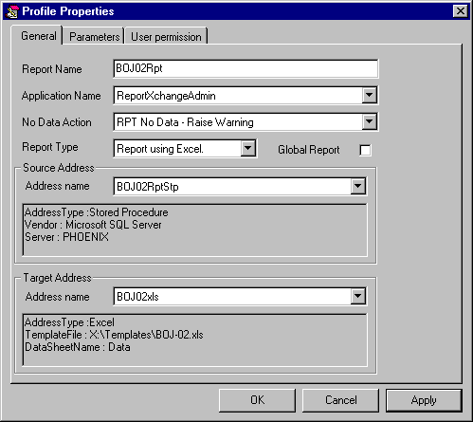

  - “ReportNameRpt” is the convention for the Report Name
- Message Log Extract linked to Message Log Crystal Report
  - as shown below

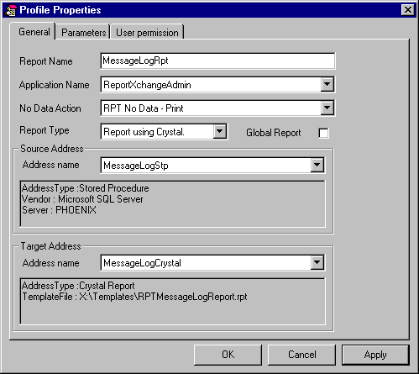

  - “MessageLogRpt” is the convention for the Report Name

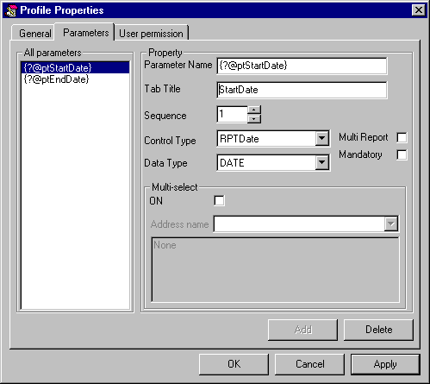

  - two parameters must be set up for this as above
    - {?@ptStartDate}
      - Tab Title – Start Date
    - {?@ptEndDate}
      - Tab Title – End Date

Report Templates

There are two stages to setting up report templates. Firstly, in Report Explore, the report groups and reports (which includes data transfers) should be set up. Secondly the templates for the data transfer and reports need to be set up.

(A report template is essentially a stored version of a report profile, but with enough information to print it. That is, with printer details, and most importantly, any parameters completed – for example, the relevant dates for a report.)

- in Report Explorer, a number of groups should be set up
  - right click on the Report Structure icon within Report Explorer, and choose Add group
  - enter an appropriate group name
- to each of the groups set up, reports (and data transfers) should be added
  - right click on the group name, and choose Add report to group
  - select form the list of available reports (note this list is populated dependent on login, and user permissions set up in Profile Maintenance)
- to set up a template, right click on the report (or data transfer) and choose Templates

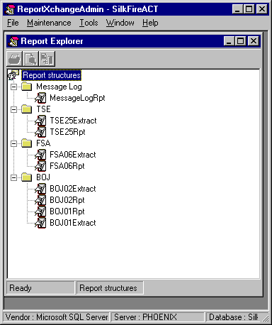

Daily Procedures for Printing Reports
The normal daily flow of events with scheduling and processing of reports is as follows :
- the data file(s) is loaded into the SilkFire data folder (note this may be done directly by extract stores procedures)
- a scheduled process is run to carry out the data transfer(s), and then to produce the required reports (print using report templates)
- the SilkFire Data Status Report is run and checked, to ensure data has been loaded correctly. This can also be done as a scheduled process
- the list of processes run is checked in Maintenance/Process within ReportXchange Admin. Each should have a completed status
- the reports themselves are checked to ensure they have all printed, and have the correct data
Checking the Data File (if applicable)
Before reports can be printed for a particular date, the data file(s) must be received into the SilkFire data folder, and imported to the SilkFire database. Data files are delivered almost every business day for previous dates, usually for the date, two business days before today’s date. On certain days, data is delivered for weekly and monthly reports as well as daily reports.
To check if the data file(s) has arrived, look in the SilkFire data folder. This is the location defined when the Address for the data feed file(s) was set up using ReportXchange Admin.
There will also be a number of processed data files in this folder, with appended datetime stamps - for example, All.200620001045. These are backup copies of data files which have been processed (in the example, this file was loaded to the database on 20th June 2000 at 10:45 am). As soon as a data file is successfully loaded onto the database, its name is changed to reflect the date and time of loading.
Scheduled Loading of Data File (if applicable)
The automatic scheduled process will run every business day. If the data file is present in the SilkFire data folder, it will be loaded to the database and its name will be changed to the timestamp name.
If the scheduled process does not run for any reason, it is possible to manually run the data feed process using ReportXchange Admin.
Manual Loading of a Data File (if applicable)
If the scheduled data feed does not run, it is necessary to manually run the data feed in order to get the data into the SilkFire database for reporting.
- check the data file is in the SilkFire data folder. Note the other files in that folder are timestamped at the time they were loaded to the database
- run ReportXchange Admin, and login is as User RPTAdmin,
- select Maintenance/Process
- delete all the existing completed processes from the list by clicking on a record and then clicking on the Delete icon on the toolbar
- add a new record by clicking the Add New Record icon on the toolbar.
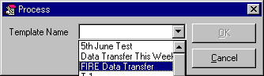
- select the “FIRE Data Transfer” template and click OK
- the data load process should complete within a few seconds
- click on the “Refresh the list” icon on the toolbar. The Process Status column should have changed to Completed. If it indicates that an error occurred, the Message Log report from the Report Explorer should be printed out to show the cause.

Checking the SilkFire Data Status (if applicable)
In order to check that data has been correctly loaded, the SilkFire Data Status report should be checked. This can either be run as a scheduled process, or can be run from File/Report Explorer in ReportXchange Admin (in this case, click on the SilkFire Data Status report node, and use the right-click menu to print or preview the report).
Examine the report, to determine whether data has been loaded for the date in question. The report shows if data is missing or if there is a “No Data” tag in the database. A “No Data” tag is a special record in the data feed that signifies that data has been delivered for the report and date, but that there was no relevant data to report. This means that a zero-filled or blank report is correct and represents no trading or positions for the type of report and date. It is important to know whether data has simply not arrived, or that there is actually nothing to report. Depending on the type of report, this could mean that the report does or does not have to be submitted for that date. If a report and date combination is missing for the period chosen, this signifies that the correct data has not been received.

Manual Procedures for Printing Reports

There are several different ways to manually print reports with SilkFire, using the File/Report Explorer option within ReportXchange Admin. Each of the options is accessed through the right-click menu. On the Report Explorer, click on the report to be printed, then use the right mouse button to bring up the right-click menu. The same options exist for both printing and previewing the reports.
Print
A parameter dialog is displayed and the user must select the report date from the calendar control provided, and then click OK.
Print with Template
This option brings up a sub-menu (see below) showing the templates that have been predefined for this report. In this case, the report parameter (report date) does not have to be selected, as it has already been pre-defined.
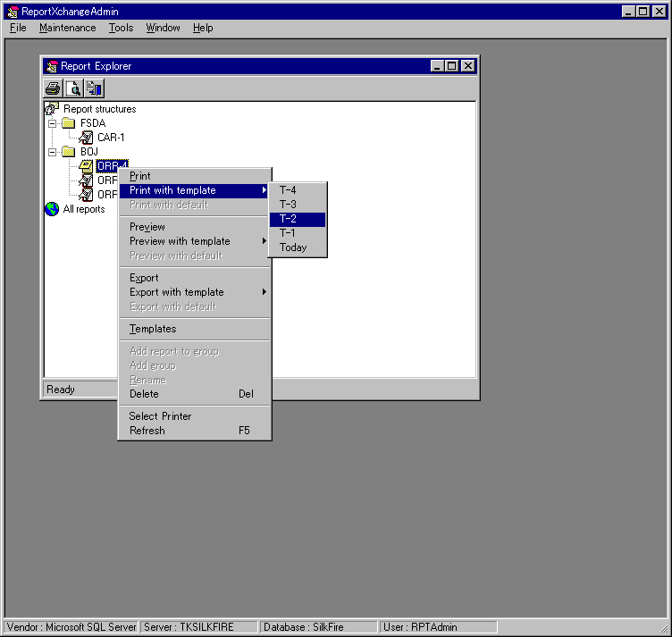
The screen shot above shows the ‘right-click’ menu from the ORR4 report, and the ‘Print with template’ submenu. The submenu shows the five pre-defined report templates that have been set up for this report. The Today report template will print the report using today’s date as the report parameter. T-1 uses yesterdays date; T-2 uses the day before, etc.
Note , the “T-“ notation does not account for business days, so if today is Monday, and Friday’s report is required, the T-3 report template should be selected (not T-1).
Print with Default
One of the pre-defined report templates can be defined to be the default report template, in which case that parameter is used when the ‘Print with default’ option is selected.
Print with Template
This is done in the same way as printing a report above.

Appendix

Sample Reports
About InVitesse
Systems Consultancy
InVitesse provides Systems Consultancy services with particular focus in the areas of research applications, and transaction processing systems. We are able to advise clients on streamlining business process models and workflows either through the use of our solutions, client in-house systems or other third party software.
Project Management
InVitesse Project Managers specialize in the planning and implementation of our software solutions. Our years of experience and knowledge enable us to deliver projects to schedule and to our client's requirements.
Systems Integration
InVitesse will work with a client to integrate our applications with the client’s in-house systems, whether they are bespoke developed or third-party packages.
Systems Support
InVitesse provides both on-site and off-site technical support to our clients depending on the client’s requirements. We support both SilkRoad and InVitesse applications locally in Tokyo.

Contact Details in Japan
Huw R. Williams
The InVitesse Group Ltd
Japan
Tel: +81-3-5545 4638
Fax:+81-3-5545 4637

huw.williams@InVitesse.com
http:\\www.invitesse.com

Contact Details in Vietnam
David Appleton
SilkRoad (Vietnam) Limited
101 Nguyen Cong Tru Street
District 1
Ho Chi Minh City
Viet Nam
Tel: +84 8 914 1970
Fax: +84 8 914 1971
Mob: +84 90 301 4488
Japan: +81 90 4457 5955
mailto:David.Appleton@SilkRoad-net.com
http:\\www.silkroad-net.com

